Open enrollment—ready-to-use benefit guide content
Instructions to plan sponsor: Use this content block in your open-enrollment benefit communication to remind your participants about the benefits of their retirement plan offered through John Hancock. Please copy and paste this text into your annual
open-enrollment communication. Remember to remove this gray instruction box and select and update the yellow-highlighted content below according to your plan.
John Hancock Retirement Plan Services LLC, 200 Berkeley Street, Boston, MA 02116
NOT FDIC INSURED. MAY LOSE VALUE. NOT BANK GUARANTEED.

© 2023 John Hancock. All rights reserved.

MGS-P42692 GE 8/23 44945 MGR0810233046290

Make the most of your retirement plan benefit
As part of your benefits package, you have access to the <INSERT PLAN NAME> (plan) offered through John Hancock. If you’re not currently participating in the retirement plan—and are eligible* to do so—consider enrolling to start saving for retirement today.

You can enroll, review your account, request a summary plan description (SPD), and access a wide variety of financial wellness tools at myplan.johnhancock.com or by downloading John Hancock’s retirement app. R

Download John Hancock’s retirement app quickly and easily using the QR codes below.

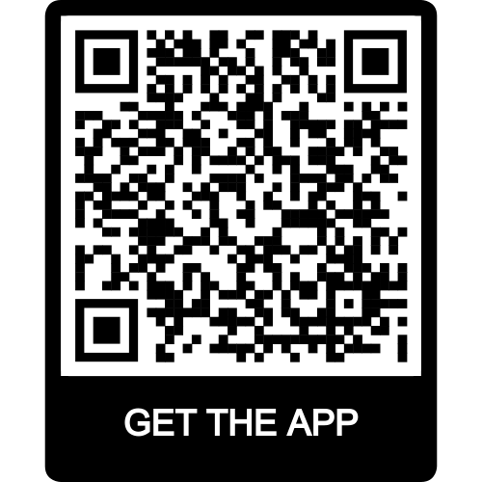

Elect a beneficiary for your retirement plan
The beneficiaries you’ve selected for your health and welfare benefits don’t carry over to your retirement plan. Please be sure to review and update, or designate, a beneficiary for your retirement plan. To name or update your plan beneficiary, visit myplan.johnhancock.com or John Hancock’s retirement app. To name or update your plan beneficiary, contact <INSERT CONTACT>/complete the beneficiary designation form.

Plan for the retirement you want
John Hancock, your retirement plan provider, offers solutions designed to help personalize your retirement strategy and improve your overall financial health. Explore the benefits and tools available through your plan at myplan.johnhancock.com or John Hancock’s retirement app.

* Consult your plan’s SPD for eligibility.

